Name : Vishnu Ram
Email : vishnuram1896@gmail.com
Github :

Assignment 4: Automatic EBS Snapshot and Cleanup Using AWS Lambda and Boto3

Objective
Automate the creation of EBS snapshots and delete snapshots older than 3 minutes using AWS Lambda and Boto3.

Introduction
This assignment uses AWS Lambda, IAM, S3, CloudWatch, and Boto3 to automatically identify unencrypted S3 buckets.

AWS Services Used
Amazon S3, AWS Lambda, AWS IAM, Amazon CloudWatch, Boto3 SDK

Step 1: Create or Identify an EBS Volume
- Login to AWS console
- Using Existing EC2 Instance Volume.
- Note the Volume ID.
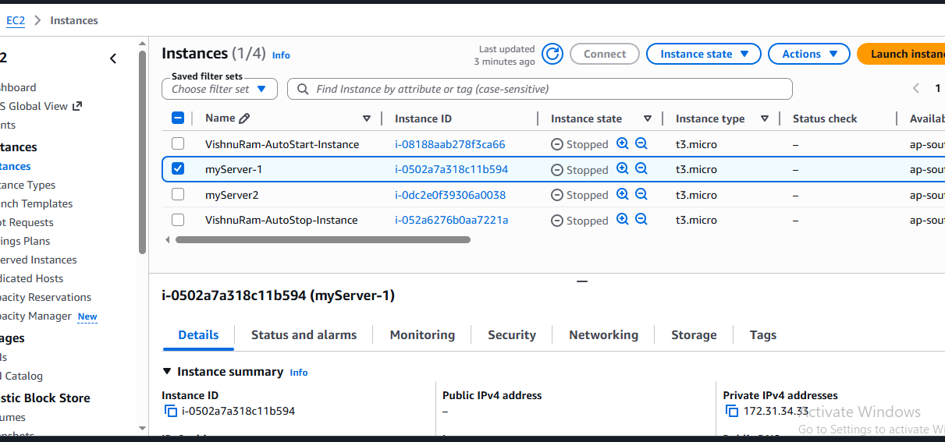

Then Create new EBS Volume:
- Go to EC2
- Elastic Block Store
- Volume
- Create Volume
- Provide Volume Type, Size, Availability Zone.
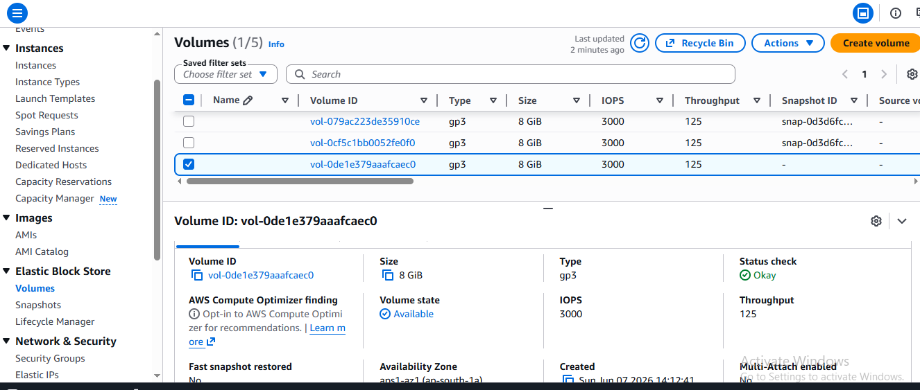

Step 2: IAM Role Creation

Procedure
- Opened the IAM Dashboard.
- Selected Roles.
- Clicked Create Role.
- Selected AWS Service as trusted entity.
- Selected Lambda as the use case.
- Attached the following policy:
- AmazonEC2FullAccess
- Created the role successfully.
- Role Name : EBSSnapshotLambdaRole

Outcome
An IAM role was created with permissions required to access.

Screenshot: IAM Role Creation.
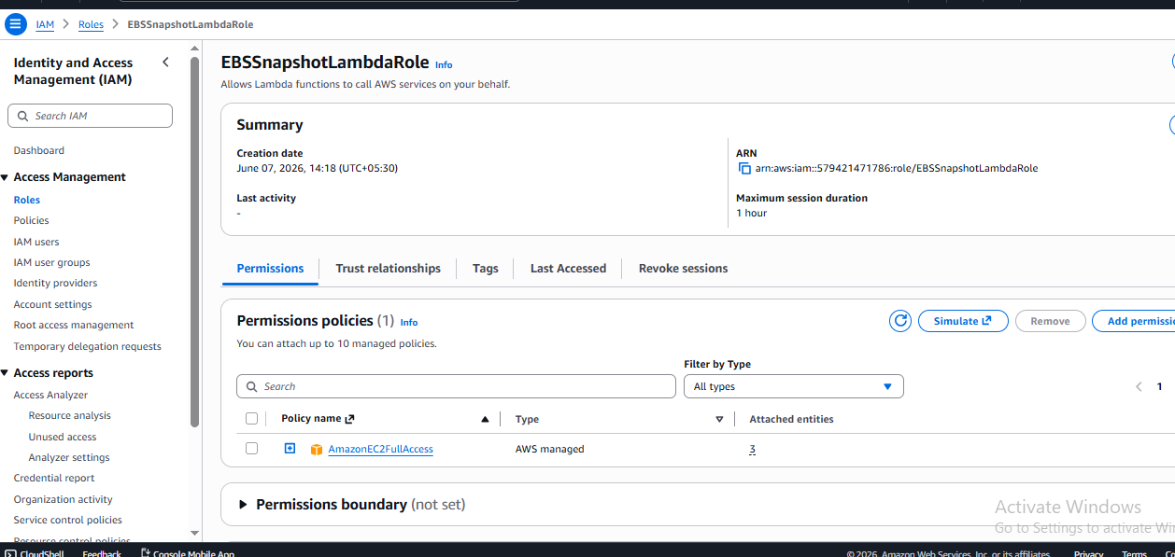

Step 3: Lambda Function Creation

Procedure
- Opened AWS Lambda Console.
- Clicked Create Function.
- Selected Author From Scratch.
- Entered Function Name.
- Selected Python Runtime.
- Assigned the IAM Role created previously.
- Created the Lambda Function.
- Lambda Function Name : EBSBackupCleanup

Outcome
Lambda function was successfully created and configured.
Screenshot: Lambda Function Configuration.
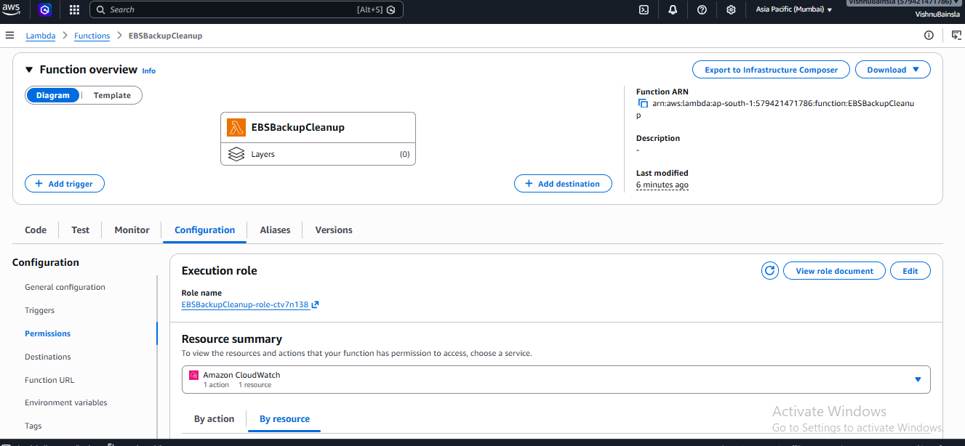

Step 4: Lambda Function Code
The Lambda code used in the assignment.
Screenshot
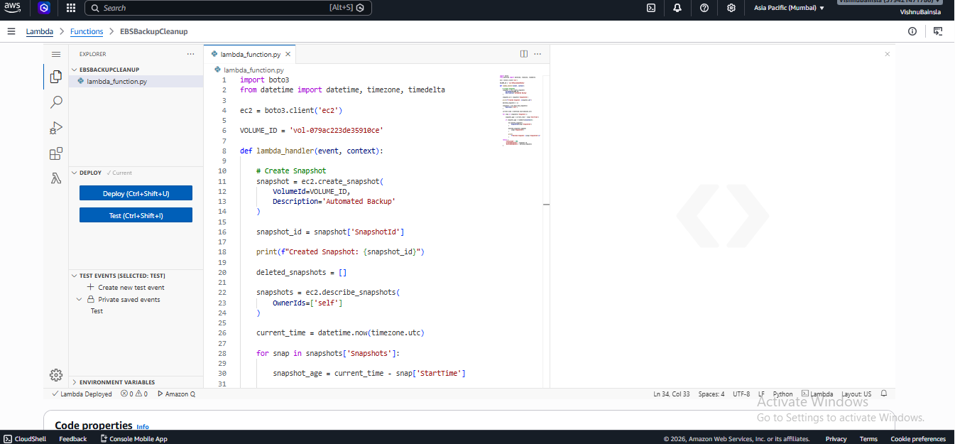

Step 5: Testing
- Click on Deploy button.
- Test the Lambda function.
- Run the Code
- Success
Screenshot
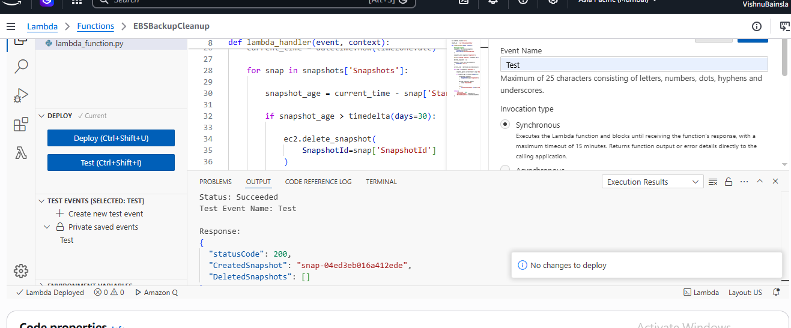

Step 6: Verify Snapshot Creation
- Go to EC2
- Snapshots and now verify Automated Backup.
Screenshot
- 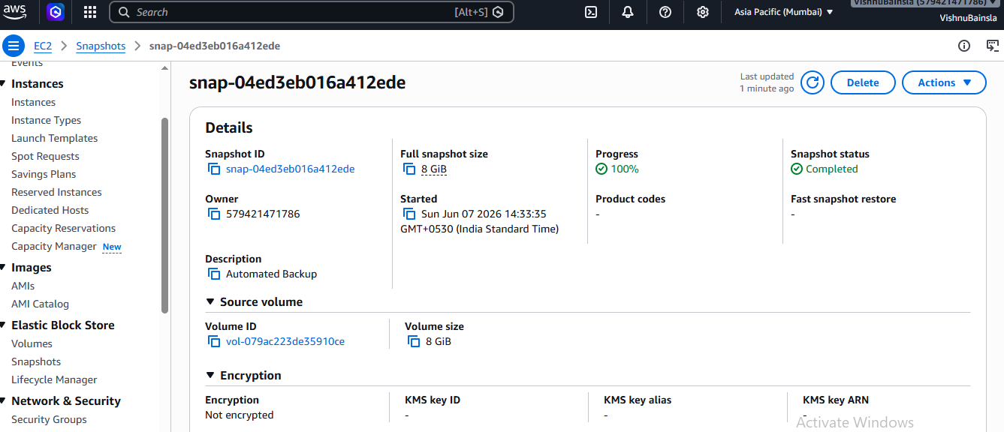
- 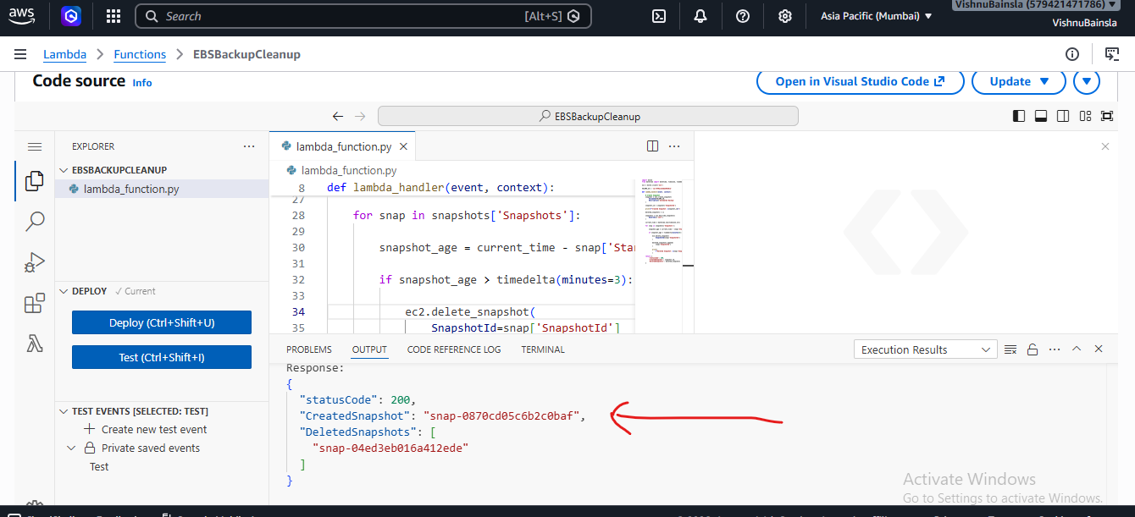

Verify CloudWatch Logs:
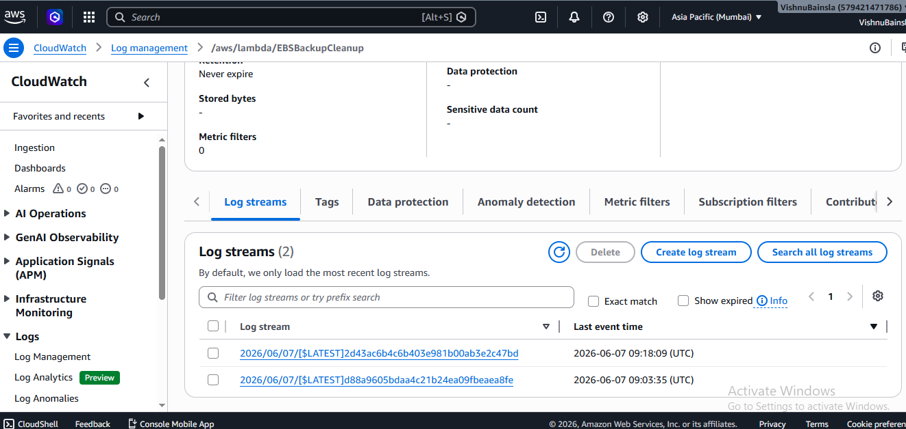

Bonus: Automatic Weekly Backup:
Create EventBridge Rule:
- Go to Amazon EventBridge
- Create Rule
- Rule Name like WeeklyEBSBackup.
- Then Select option like schedule - Rate Expression – 7 Days
- Now Target Lambda function

Results
